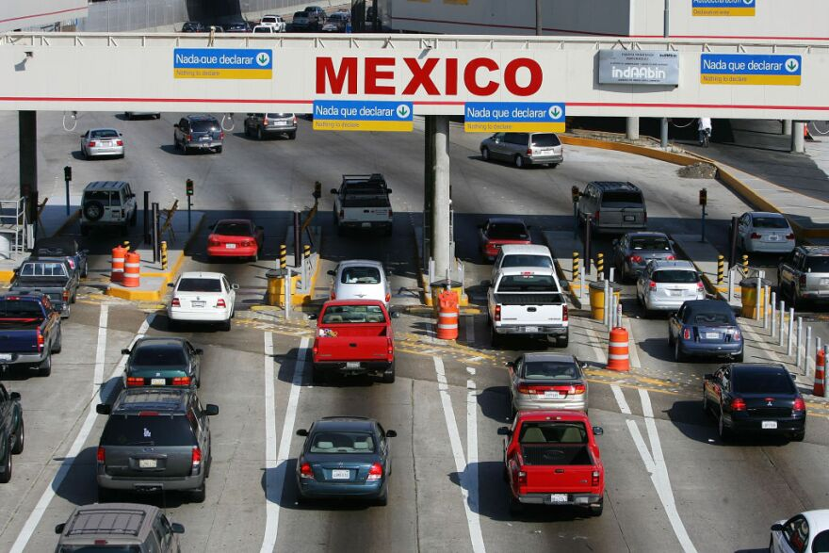

**BGP LAB**

Brendon Ahn | Advanced Cisco | 2022-2023



**Purpose**

To connect an OSPF and EIGRP network using BGP protocol

**Background**

BGP or Border Gate Protocol is an exterior gateway protocol used to exchange routing between networks. BGP is something called a path-vector routing protocol that keeps the path information that updates automatically. BGP is applied on the border routers to pass packets through to either the internet or another network.

Another name for BGP is the “three-napkin protocol” because it was sketched on the back of “three ketchup stained napkins” by engineers in 1989. BGP has been in use on the internet since 1994 and IPV6 was defined that same year.

BGP is configured amongst “peers”, adjacent routers, manually. A packet is sent every 30 seconds to maintain connection. BGP has 6 states: Idle, Connect, Active, Open Sent, Open Confirm, and Established. The states progress in that order. The networks that are using BGP must be full mesh for it to work.

Because BGP is a way to easily connect two networks it is very important for businesses that want to be able to send packets internally without being able to access the routing table of the connecting network. There are different BGP variations like eBGP and iBGP which have different applications.

**Lab Summary**

We learned EIGRP and connected it to OSPF using BGP. We had to get two pcs connected to each of the networks to ping each other.

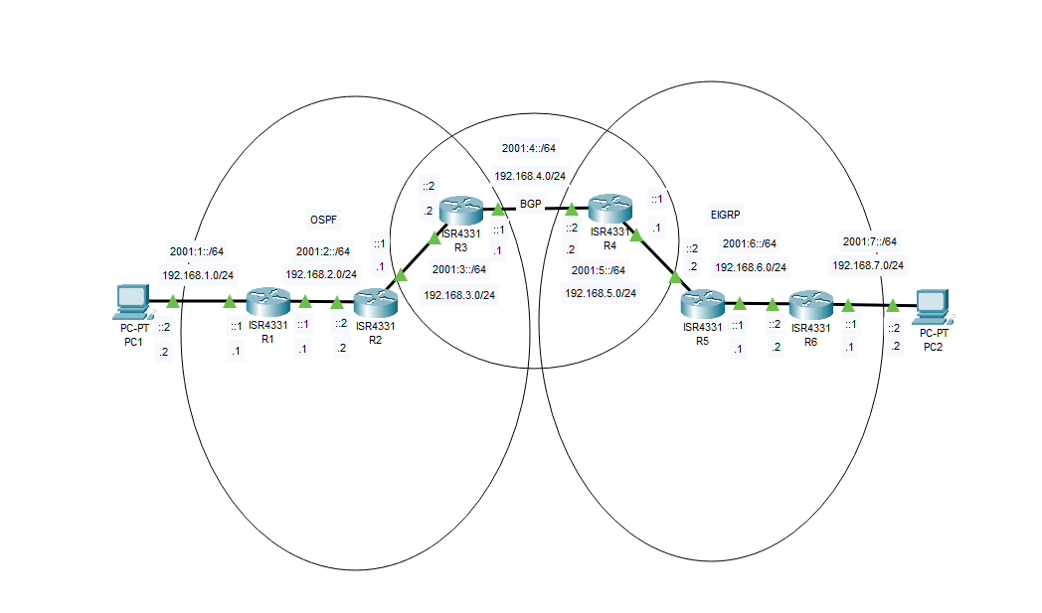

**Topology**

**Lab Commands**

Router(config)# router EIGRP <protocol id>”

With the id range being 1-65535 The command, like Router(config)# router OSPF <protocol id>is used to enable EIGRP on the router as well as determine a process id.

Router(config-router)# redistribute bgp <process id> metric <metrics>

This command is used to create a mutual redistribution between EIGRP and BGP, which allows packets to be transferred across the different routing protocols. In addition to the EIGRP

Router(config)# router BGP <process id>”

This command is similar in function to Router(config)# router EIGRP <protocol id>” but instead of EIGRP, it enables BGP.

Router(config-router)# BGP log-neighbor-changes” which toggles on and off the logging of BGP neighbor status change messages, those being comes up, goes down, and resets. The next BGP commands I used were “config-router# neighbor <ipv4 address> remote-as <bgp process id>” and “config-router# neighbor <ipv4 address> next-hop-self” These two commands defined the neighboring device address and the next-hop address of its own interface that connects to said neighbor.

**Router Configurations**

Router 1:

Current configuration : 1890 bytes

Last configuration change at 21:49:36 UTC Mon Oct 3 2022

version 16.7

service timestamps debug datetime msec

service timestamps log datetime msec

platform qfp utilization monitor load 80

no platform punt-keepalive disable-kernel-core

hostname R1

boot-start-marker

boot-end-marker

vrf definition Mgmt-intf

address-family ipv4

exit-address-family

address-family ipv6

exit-address-family

no aaa new-model

no ip domain lookup

subscriber templating

vtp domain cisco

vtp mode transparent

ipv6 unicast-routing

multilink bundle-name authenticated

license udi pid ISR4321/K9 sn FDO220523GF

no license smart enable

diagnostic bootup level minimal

spanning-tree extend system-id

redundancy

mode none

interface GigabitEthernet0/0/0

ip address 192.168.2.1 255.255.255.0

negotiation auto

ipv6 address 2001:2::1/64

ipv6 ospf 1 area 0

interface GigabitEthernet0/0/1

ip address 192.168.1.1 255.255.255.0

negotiation auto

ipv6 address 2001:1::1/64

ipv6 ospf 1 area 0

interface Serial0/1/0

no ip address

shutdown

interface Serial0/1/1

no ip address

shutdown

interface GigabitEthernet0/2/0

no ip address

shutdown

negotiation auto

interface GigabitEthernet0/2/1

no ip address

shutdown

negotiation auto

interface GigabitEthernet0

vrf forwarding Mgmt-intf

no ip address

shutdown

negotiation auto

router ospf 1

router-id 1.1.1.1

network 192.168.1.0 0.0.0.255 area 0

network 192.168.2.0 0.0.0.255 area 0

ip forward-protocol nd

ip http server

ip http authentication local

ip http secure-server

ip tftp source-interface GigabitEthernet0

ipv6 router ospf 1

router-id 1.1.1.1

control-plane

line con 0

transport input none

stopbits 1

line aux 0

stopbits 1

line vty 0 4

login

wsma agent exec

wsma agent config

wsma agent filesys

wsma agent notify

end

Router 2:

Current configuration : 4014 bytes

Last configuration change at 21:24:39 UTC Mon Oct 3 2022

version 16.9

service timestamps debug datetime msec

service timestamps log datetime msec

platform qfp utilization monitor load 80

platform punt-keepalive disable-kernel-core

hostname R2

boot-start-marker

boot-end-marker

vrf definition Mgmt-intf

address-family ipv4

exit-address-family

address-family ipv6

exit-address-family

no aaa new-model

login on-success log

subscriber templating

vtp domain cisco

vtp mode transparent

ipv6 unicast-routing

multilink bundle-name authenticated

license udi pid ISR4321/K9 sn FDO21482DXE

no license smart enable

diagnostic bootup level minimal

spanning-tree extend system-id

redundancy

mode none

interface GigabitEthernet0/0/0

ip address 192.168.3.1 255.255.255.0

negotiation auto

ipv6 address 2001:3::1/64

ipv6 ospf 1 area 0

interface GigabitEthernet0/0/1

ip address 192.168.2.2 255.255.255.0

negotiation auto

ipv6 address 2001:2::2/64

ipv6 ospf 1 area 0

interface Serial0/1/0

no ip address

shutdown

interface Serial0/1/1

no ip address

shutdown

interface GigabitEthernet0/2/0

no ip address

shutdown

negotiation auto

interface GigabitEthernet0/2/1

no ip address

shutdown

negotiation auto

interface GigabitEthernet0

vrf forwarding Mgmt-intf

no ip address

shutdown

negotiation auto

router ospf 1

router-id 2.2.2.2

network 192.168.2.0 0.0.0.255 area 0

network 192.168.3.0 0.0.0.255 area 0

ip forward-protocol nd

ip http server

ip http authentication local

ip http secure-server

ip tftp source-interface GigabitEthernet0

ipv6 router ospf 1

router-id 2.2.2.2

control-plane

line con 0

transport input none

stopbits 1

line aux 0

stopbits 1

line vty 0 4

login

end

Router 3:

Current configuration : 4097 bytes

Last configuration change at 19:35:34 UTC Wed Oct 5 2022

version 16.9

service timestamps debug datetime msec

service timestamps log datetime msec

platform qfp utilization monitor load 80

platform punt-keepalive disable-kernel-core

hostname R3

boot-start-marker

boot-end-marker

vrf definition Mgmt-intf

address-family ipv4

exit-address-family

address-family ipv6

exit-address-family

no aaa new-model

no ip domain lookup

login on-success log

subscriber templating

vtp domain cisco

vtp mode transparent

ipv6 unicast-routing

multilink bundle-name authenticated

license udi pid ISR4321/K9 sn FDO21500G1N

no license smart enable

diagnostic bootup level minimal

spanning-tree extend system-id

redundancy

mode none

interface GigabitEthernet0/0/0

ip address 192.168.4.1 255.255.255.0

negotiation auto

ipv6 address 2001:4::1/64

interface GigabitEthernet0/0/1

ip address 192.168.3.2 255.255.255.0

negotiation auto

ipv6 address 2001:3::2/64

ipv6 ospf 1 area 0

interface Serial0/1/0

interface Serial0/1/1

interface GigabitEthernet0/2/0

no ip address

shutdown

negotiation auto

interface GigabitEthernet0/2/1

no ip address

shutdown

negotiation auto

interface GigabitEthernet0

vrf forwarding Mgmt-intf

no ip address

shutdown

negotiation auto

router ospf 1

router-id 3.3.3.3

redistribute bgp 1 metric 500 subnets

network 192.168.3.0 0.0.0.255 area 0

router bgp 1

bgp log-neighbor-changes

network 192.168.4.0

neighbor 192.168.4.2 remote-as 1

neighbor 192.168.4.2 next-hop-self

ip forward-protocol nd

ip http server

ip http authentication local

ip http secure-server

ip tftp source-interface GigabitEthernet0

ipv6 router ospf 1

router-id 3.3.3.3

control-plane

line con 0

transport input none

stopbits 1

line aux 0

stopbits 1

line vty 0 4

login

end

Router 4:

Current configuration : 1700 bytes

Last configuration change at 19:54:01 UTC Wed Oct 5 2022

version 15.5

service timestamps debug datetime msec

service timestamps log datetime msec

no platform punt-keepalive disable-kernel-core

hostname R4

boot-start-marker

boot-end-marker

vrf definition Mgmt-intf

address-family ipv4

exit-address-family

address-family ipv6

exit-address-family

no aaa new-model

no ip domain lookup

login on-success log

subscriber templating

vtp domain cisco

vtp mode transparent

ipv6 unicast-routing

subscriber templating

vtp domain cisco

vtp mode transparent

multilink bundle-name authenticated

license udi pid ISR4321/K9 sn FDO21441WDF

spanning-tree extend system-id

redundancy

mode none

vlan internal allocation policy ascending

vlan 10

name Apple

vlan 20

name Facebook

interface GigabitEthernet0/0/0

ip address 192.168.5.1 255.255.255.0

negotiation auto

ipv6 address 2001:5::1/64

ipv6 eigrp 1

interface GigabitEthernet0/0/1

ip address 192.168.4.2 255.255.255.0

negotiation auto

ipv6 address 2001:4::2/64

interface Serial0/1/0

interface Serial0/1/1

interface GigabitEthernet0

no ip address

shutdown

negotiation auto

interface Vlan1

no ip address

shutdown

router eigrp 1

network 192.168.5.0

redistribute bgp 1 metric 500 10 255 1 1500

eigrp router-id 4.4.4.4

router bgp 1

bgp log-neighbor-changes

network 192.168.4.0

neighbor 192.168.4.1 remote-as 1

neighbor 192.168.4.1 next-hop-self

ip forward-protocol nd

no ip http server

no ip http secure-server

ip tftp source-interface GigabitEthernet0

ipv6 router eigrp 1

eigrp router-id 4.4.4.4

control-plane

line con 0

stopbits 1

line aux 0

stopbits 1

line vty 0 4

login

end

Router 5:

Current configuration : 1721 bytes

Last configuration change at 22:09:34 UTC Mon Oct 3 2022

version 15.5

service timestamps debug datetime msec

service timestamps log datetime msec

no platform punt-keepalive disable-kernel-core

hostname R5

boot-start-marker

boot-end-marker

vrf definition Mgmt-intf

address-family ipv4

exit-address-family

address-family ipv6

exit-address-family

no aaa new-model

no ip domain lookup

ipv6 unicast-routing

subscriber templating

vtp domain cisco

vtp mode transparent

multilink bundle-name authenticated

license udi pid ISR4321/K9 sn FDO214420HM

spanning-tree extend system-id

redundancy

mode none

vlan internal allocation policy ascending

vlan 10

name Apple

vlan 20

name Facebook

interface GigabitEthernet0/0/0

ip address 192.168.6.1 255.255.255.0

negotiation auto

ipv6 address 2001:6::1/64

ipv6 eigrp 1

interface GigabitEthernet0/0/1

ip address 192.168.5.2 255.255.255.0

negotiation auto

ipv6 address 2001:5::2/64

ipv6 eigrp 1

interface Serial0/1/0

no ip address

shutdown

interface Serial0/1/1

no ip address

shutdown

interface GigabitEthernet0

no ip address

shutdown

negotiation auto

interface Vlan1

no ip address

shutdown

router eigrp 1

network 192.168.5.0

network 192.168.6.0

eigrp router-id 5.5.5.5

router bgp 2

bgp router-id 5.5.5.5

bgp log-neighbor-changes

no bgp default ipv4-unicast

ip forward-protocol nd

no ip http server

no ip http secure-server

ip tftp source-interface GigabitEthernet0

ipv6 router eigrp 1

eigrp router-id 5.5.5.5

control-plane

line con 0

stopbits 1

line aux 0

stopbits 1

line vty 0 4

login

end

Router 6:

Last configuration change at 22:28:57 UTC Fri Oct 21 2022

version 15.5

service timestamps debug datetime msec

service timestamps log datetime msec

platform punt-keepalive disable-kernel-core

hostname R6

boot-start-marker

boot-end-marker

vrf definition Mgmt-intf

address-family ipv4

exit-address-family

address-family ipv6

exit-address-family

no aaa new-model

login on-success log

ipv6 unicast-routing

subscriber templating

multilink bundle-name authenticated

license udi pid ISR4321/K9 sn FDO214414VU

spanning-tree extend system-id

redundancy

mode none

vlan internal allocation policy ascending

interface GigabitEthernet0/0/0

ip address 192.168.6.2 255.255.255.0

negotiation auto

ipv6 address 2001:6::2/64

ipv6 enable

ipv6 eigrp 1

interface GigabitEthernet0/0/1

ip address 192.168.7.1 255.255.255.0

negotiation auto

ipv6 address 2001:7::1/64

ipv6 enable

ipv6 eigrp 1

interface Serial0/1/0

no ip address

shutdown

interface Serial0/1/1

no ip address

shutdown

interface GigabitEthernet0

vrf forwarding Mgmt-intf

no ip address

shutdown

negotiation auto

interface Vlan1

no ip address

shutdown

router eigrp 1

network 192.168.6.0

network 192.168.7.0

ip forward-protocol nd

no ip http server

no ip http secure-server

ip tftp source-interface GigabitEthernet0

ipv6 router eigrp 1

eigrp router-id 6.6.6.6

control-plane

line con 0

stopbits 1

line aux 0

stopbits 1

line vty 0 4

login

end

**Proof**

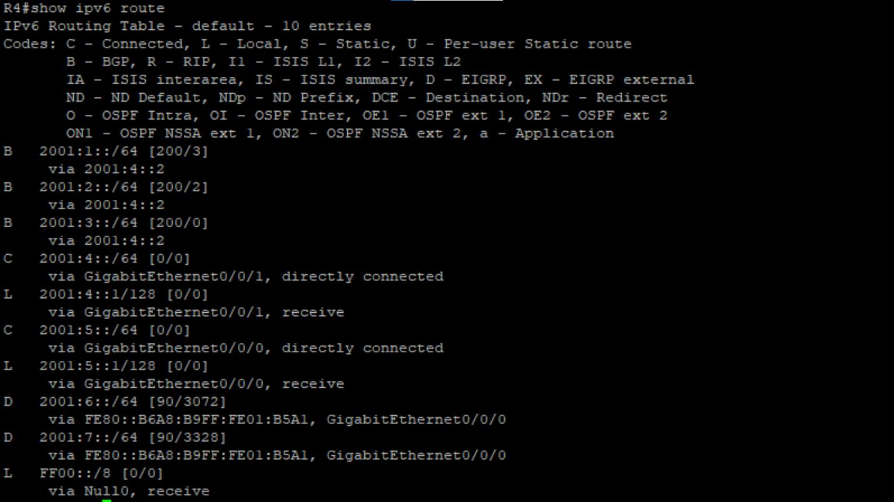 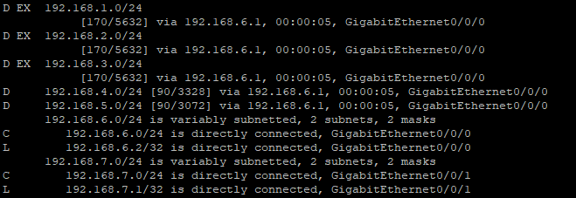 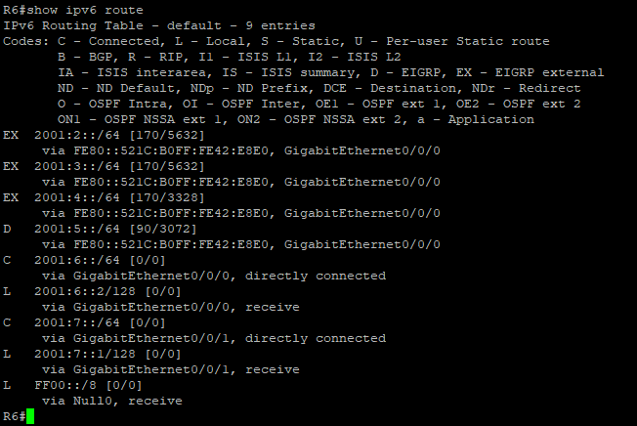 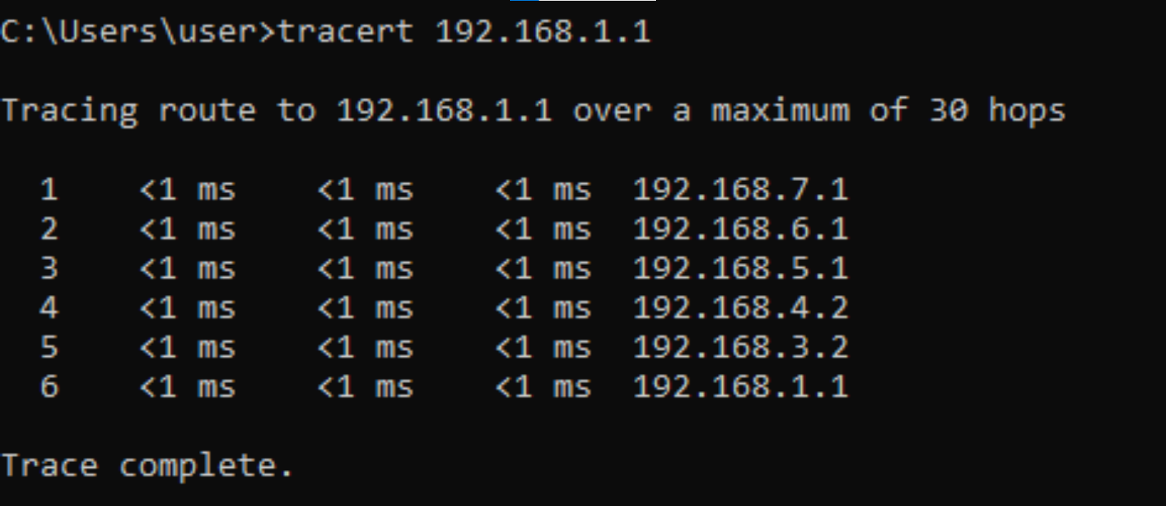

**Problems**

My drive corrupted one time, so I had to restart the entire lab because I was the only one with the lab saved. During the actual lab we had to learn how to get Eigrp to work as well as BGP which was a massive struggle. We didn’t realize that a redistribute connected was necessary on the connected routers. When the routes would stop at the bgp routers, and we didn’t understand why.

My drive then corrupted a second time limiting what things I had saved and thus this write up isn’t really up to par. BGP metrics was something we also didn’t really understand which became an issue. On one of our configs when setting it up it had two addresses which broke our network and we didn’t find the issue for a long time.

**Conclusion**

We had to learn not only how to set up Eigrp v2 and v3 as well as learning how to set up bgp. This had to be done on a 6-router network with two pcs. 3 of the routers doing OSPF had to be connected to 3 Eigrp routers using bgp in between the 2 center routers. One pc connected to OSPF the other to EIGRP and they had to be able to ping each other.